Nicholas Skinner

CS 493

Fall 2019

**Project #6: Keytime Animation**

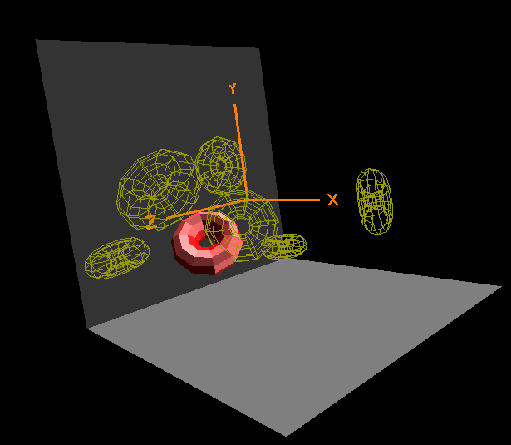

****I didn’t mention it in the video, but this all occurs within 10 seconds*****

Video link: <https://media.oregonstate.edu/media/t/0_llztby6i>